P4 – ELECTRICAL CiRCUITS

Contents:

Headings:

Electrical Components

Charge

Ammeters, Voltmeters and Resistance

Parallel and Series

Equations:

Charge

Resistance

Component Graphs:

Filament Bulb

Diode

Fixed Resistor

Required Practical’s

How does the length of a wire affect resistance?

Investigating Components

R-J Sammé

Science

This content is not intended to be modified or redistributed in any way. © R-J Sammé 2021

Revision – P4

Electrical Components

Cell – Pushes electrons around a circuit. A battery is **two or more** cells, and the + sign represents the positive terminal. A charge flows from the **negative** terminal to the positive.

Switch – Allows you to stop or start the flow of current in a circuit. This is an **open** switch, a **closed** switch has no gap between the wires.

Bulb – Emits light when a current passes through it.

Diode – Allows current through in **one** **direction** only, as shown by the arrow.

Light Emiting Diode (LED) – A diode which lights up when a current passes through it.

Fixed Resistor – Limits the current in a circuit by a **fixed amount**.

Variable Resistor – Allows the current in a circuit to be **varied**.

Fuse – A small wire designed to melt and break the circuit if the current is **too high**.

Heater – Transfers electrical energy into **thermal** **energy** to heat the surroundings.

Ammetre – Used to measure electric **current**.

Voltmetre – Used to measure **potential difference**.

Thermistor – A temperature dependent resistor. It’s resistance **increases** as the temperature **decreases**.

Light Dependent Resistor (LDR) – The resistance of an LDR **increases** as the light intensity **decreases**.

Charge

An electrical current is a flow of charge. When a circuit is completed, electrons flow from the negative terminal of the cell/battery to the positive. Each electron carries a small electric charge. The size of an electric current is the flow of charge per second. The larger the number of electrons passing through a component, the larger the charge.

Charge is measured in **Coulombs (C)**, and can be calculated using this equation



Ammeters, Voltmeters and Resistance

Ammeters and Voltmeters can be used to measure the current(*i*) and potential difference(*v*). An ammeter can be connected in series with a component, whilst a voltmeter must be in parallel.

Series Parallel

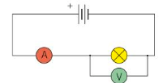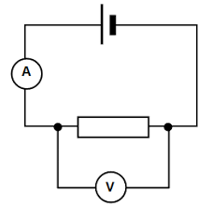

When electrons pass through a component, they are slowed down because of the vibrating particles in the component. The amount that they are slowed down is called resistance and is measured in **ohms** (**Ω**). Resistance can be calculated using this equation



Parallel and Series

In a series circuit, the current flows from one terminal of the power source to the other, powering each component in its path. Each component receives the same amount of current. The potential difference of the power supply is shared between all of the components. To calculate the total resistance in a circuit, add together the resistance of each component.

Parallel circuits are similar to series circuits, but have more than one loop. In a parallel circuit, current flows separately through each loop. This means that the total flow of charge in a parallel circuit is the sum of the current through each component. However, the potential difference across each component is the same. The total resistance in a parallel circuit is less than the resistance of the smallest resistor.

Component Characteristics

The resistance in each component is unique. In a bulb, the resistance increases as the filament in the bulb heats up. This is because, as materials heat up, the atoms vibrate faster, resisting electrons more.

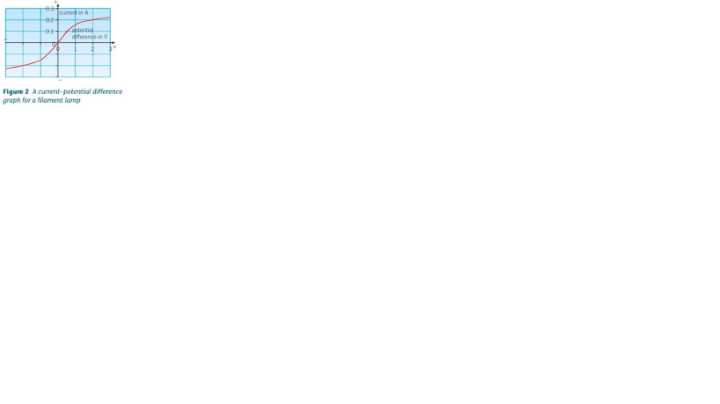

In a diode, the resistance in the forward direction is low, and the resistance in the reverse direction is high. This is because a diode only allows current to flow in one direction.

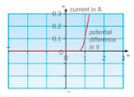

In a Resistor, the current is directly proportional (equal to) to the potential difference. This is called Ohm’s law.

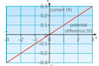

Resistance across a wire (RP)

Independent Variable – Length of the wire

Dependent Variable – Resistance

Control Variable – Thickness of wire, Number of cells

Equipment – Battery, Wires, Ammeter, Voltmeter, Variable Resistor, Wire attached to 30cm ruler, Crocodile clips.

Safety – Keep electrical equipment away from water,

Break the circuit when not in use to prevent heating of the wire.

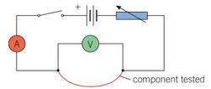

Conclusion – The results show that as the length of the wire increases, the resistance increases.

Method:

1. Setup the equipment as shown in the diagram, with one crocodile clip at 0 cm, and the other at 30 cm.
2. Measure and record the potential difference and current.
3. Move one of the crocodile clips 5 cm closer to the other
4. Repeat steps 2-3 until the clips are at 5cm
5. Calculate the resistances using your recorded data
6. Repeat steps 1-5 for more reliable results

Evaluation:

Accuracy – Use digital meters rather than analogue ones to prevent human error when reading the meter.

Reliability – Repeat the test for more reliable results.

Investigating Components (RP)

Independent Variable – Type of electrical component

Dependent Variable – Resistance

Control Variable –Number of cells

Equipment – Battery, Wires, Ammeter, Voltmeter, Variable Resistor, Bulb, LED, Diode, Crocodile clips.

Safety – Keep electrical equipment away from water.



Conclusion – The results show that resistance was affected by adding components. Resistance was highest with a Diode, and lowest with a Bulb.

Method:

1. Setup the equipment as shown in the diagram.
2. With the variable resistor at it’s lowest, measure and record the potential difference and current.
3. Adjust the variable resistor and take four more readings.
4. Repeat the above steps, replacing the bulb with a diode or LED

Evaluation:

Accuracy – Use digital meters rather than analogue ones to prevent human error when reading the meter.

Reliability – Repeat the test for more reliable results.

This document was written by R-J Samme, and is not to be modified or sold.